Greetings from Cartagena – well, sort of. We arrived there on 13 January, after an overnight sail from Almería with our good friend, Juan Peñuelas, aboard. I say “sort of,” because Vicki and I disembarked from At First Sight a few days later, rented a car, and made the 6-hour drive back to Rota, where we’re staged for Space A military flight back to the U.S.

We had been keeping our eye on the thrice monthly Patriot Express charter flight from Rota to Norfolk, but it was rescheduled for Saturday when we showed up to sign up. Good fortune came our way the following day, however, and there was plenty of space available for us on Saturday’s Patriot Express.

We’ve had two terrific port visits recently that are worth describing in greater detail, Almería and Cartagena. Having been stationed in Andalucía – now 20 years ago – we thought we knew the area pretty well, but both cities somehow escaped our attention back then. All the better to explore them now for the first time.

Almería is the eastern most port city on the famous Costa Del Sol. We had read that not many visiting yachts call on Almería because the yacht harbor is often full, and the more transient friendly harbor at Almerimar is just 5km to the west of town. But we took our chances with Almería, and we’re glad we did.

It is quite charming, really, especially when compared with the oceanfront concrete condo jungles of Málaga and Marbella to the west. And unlike Almerimar, which is reportedly kind of in the middle of nowhere, the Puerto Deportivo yacht harbor in Almería is part of the cultural district of city, literally just a few steps outside the marina. In addition, on the opposite side of the yacht harbor is a bustling commercial port with a steady flow of ocean-going ferry traffic to the Islas Baleares (Mallorca, Menorca, Ibiza, etc.) and Melilla, a Spanish enclave on the north African coast. In fact, we felt like we were about to be run over by a ferry entering the port at the same time we entered, but he jogged left into the commercial port at the last minute as we jogged right into the yacht basin.

We arrived at harbor entrance shortly after sunrise, which wasn’t until after 8AM in mid-winter, and we were moored by 09:00. The most striking feature entering around the basin isn’t a glamorous office building or an important historical monument; rather, it’s the preserved industrial remnant of an elevated rail car trestle that was used back in the day of iron ore mining from the mountains outside of town. The trestle, officially called “Cargadero de Mineral Cable Inglés” is significant because it was designed by Scottish engineers who studied under Gustave Eiffel, of Eiffel Tower fame. And good on the people of Almería for preserving this extraordinary piece of industrial heritage. On a practical note, the Cable Inglés functionally and visually separates the yacht basin from the commercial port.
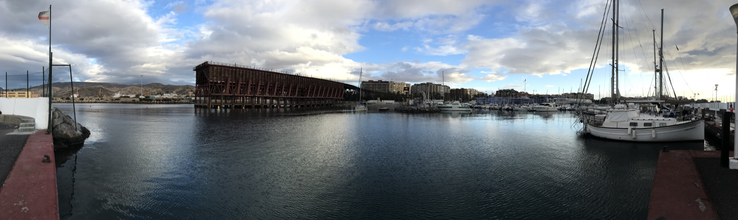
The commercial and recreational ports of Almería are separated by the Cable Inglés, an industrial artifact from a bygone era of iron mining in the nearby mountains.

Shortly after arrival, we all went ashore – David, Vicki, Juan, and Saylor – for breakfast at one of the dozens of bars and restaurants lining the beautiful oceanfront esplanade that extends a half kilometer or so to the east of the yacht harbor. Afterwards, we cleared immigration at the National Police office within the ferry terminal complex inside the commercial port. (Technically, we should have cleared immigration in Puerto Banús, after our overnight stop in Gibraltar; however, it is not a port of entry despite its reputation and feel as a Spanish version of Monaco, where the rich and famous like to be seen.)

The tourism office touts there is “much to see and do in Almería,” and they’re quite right. Like most towns in old Europe, it has its obligatory castle, church, and museum, and we saw two out three during our too short of a stay. The cathedral is a century newer than many in Spain, but it nevertheless has numerous unique architectural and religious features, including a flat roof and ramparts from which to provide defensive artillery fires if the harbor was attacked from sea.

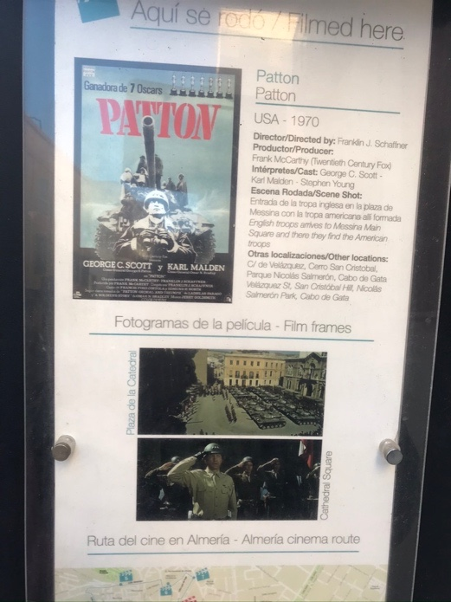
Another interesting feature about Almería is its significant role as the location shooting site for such classics as, Lawrence of Arabia, The Man from Marrakesh, Conan the Barbarian, numerous so-called Spaghetti Westerns, and my personal favorite, Patton. In fact, we had tapas in the Plaza de la Constitución, where a major scene from Patton was filmed, and it’s virtually unchanged from as it appeared in the movie.

But the pièce de résistance of our sightseeing was the Alcazaba, the well-preserved citadel ruins from the Muslim occupation of Andalucía from 712-1492 AD. Not as famous as the larger Alhambra in Granada, the Alcazaba was for me every bit as impressive a site to visit, if not more so, partly because it sits atop an imposing 250-meter precipice overlooking the heart of the old city, which gives it a commanding view of Almería harbor and bay.
Almería has been the site for many Hollywood films, including Patton.
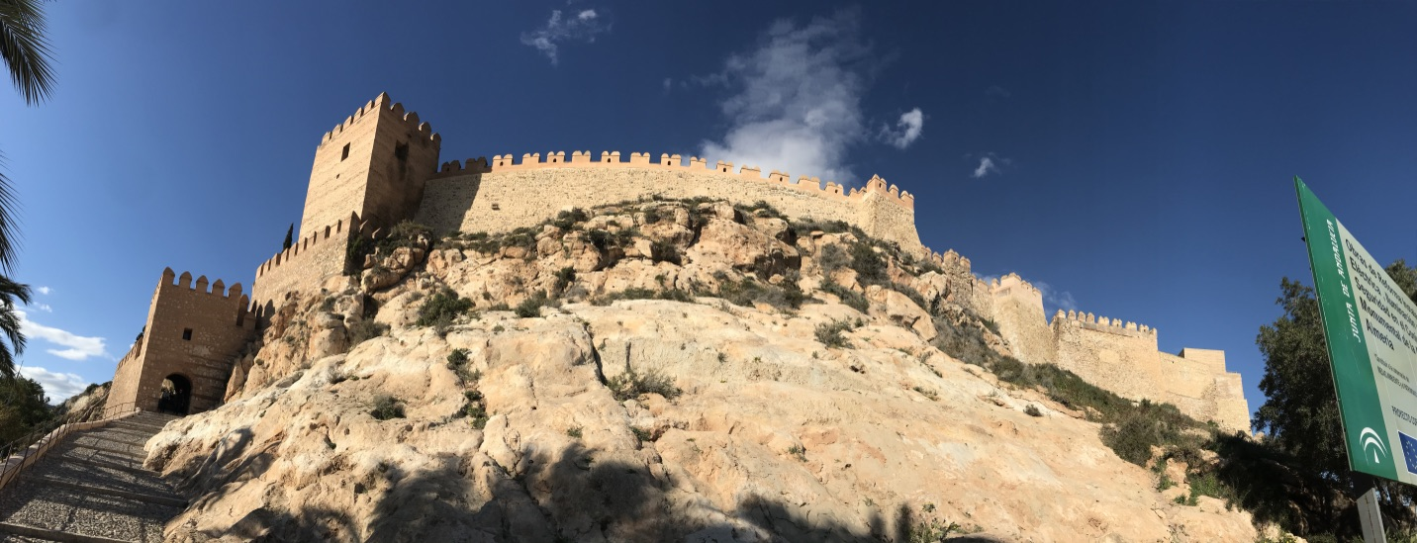
A view of the Alcazaba citadel from the city below.

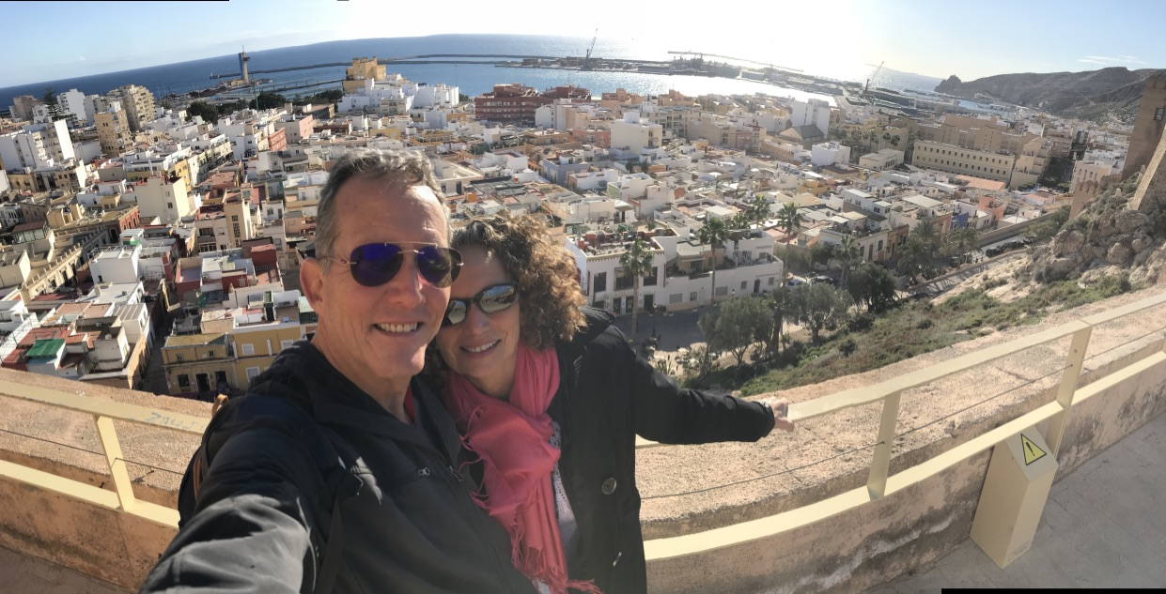
A view of the Almería from the Alcazaba.

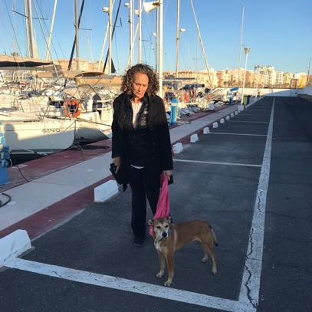
We returned to AFS content, but fully spent, after a day of sightseeing. Unfortunately, we would have to wait to take our late afternoon siesta because Saylor had escaped from the boat while we were away, yet again. Fortunately, one of the marina workers saw her shortly after she jumped ship, and he lured her into the marina office with jamón Serrano and queso Manchego. (One lucky dog!) She’s now escaped in Turks & Caicos, Dominican Republic, Puerto Rico, Bermuda (x2), Azores (overnight), and Spain.
Vicki returning from the marina office with Saylor, our resident escape artist.

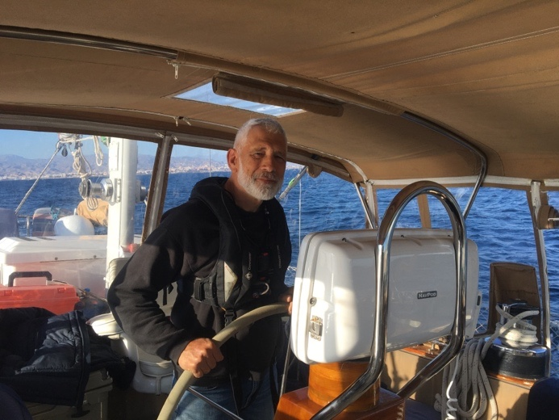
We had planned to spend another day or two in Almería, but with a change in the weather in the forecast we decided to make for Cartagena, just ~100nm to the east. Our guest, Juan, was born in Cartagena, and Paloma, his wife, was already waiting there for us. And she would need to return to work in a few days. We had no wind when we got underway late on a sunny afternoon, but it quickly freshened from the SSE, which put us on beam reach at 7kts. Yippee!
But by sundown the Mediterranean was a calm as a lake, and although we were still making 6kts it was due to Perkins power and not the wind. And so it would be, motoring throughout the night, except for a midnight tease when we had 12kts of wind for ~30 minutes. Our log indicates we sailed just 13 of 108 miles from port to port.
Leaving Almería with Juan at the helm.

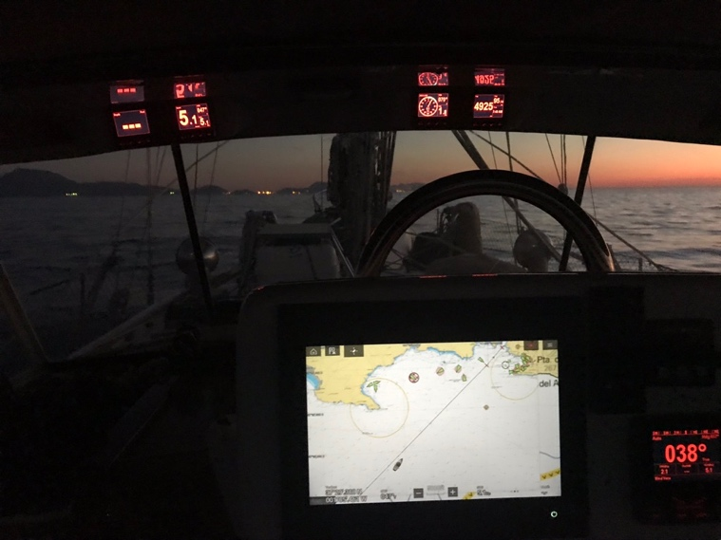
As it had been with Almería, we arrived in Cartagena shortly after sunup. Juan knew Cartagena Bay like the back of his hand, pointing out numerous places as we entered that he had fished and dove over the years. Further into the harbor lay nice yacht marinas that branch out in opposite directions from a common central wharf and access road. And despite having local knowledge aboard, we still briefly arrived and docked at the wrong marina – Yacht Port Cartagena instead of Real Club de Regatas de Cartagena (RCRC). But after a minute or two of pleasantries with the dockhand at the former, we cast off our lines and motored around Cartagena’s large cruise ship quay to arrive at the latter.
Arriving in Cartagena at daybreak.

A beautiful oasis in the desert-like mountainous province of Murcia, Cartagena has been home to the Spanish Armada for centuries. It is surrounded by five rugged mountain peaks, each with its own 18th century forteleza built to protect the port, the armada, and the city from seaborne attack. The Romans used Cartagena as a trading port at the crossroads of the eastern and western Mediterranean, and one proud resident told us they considered it “Little Rome” in part because of its five surrounding mountain peaks, compared to Rome’s seven.

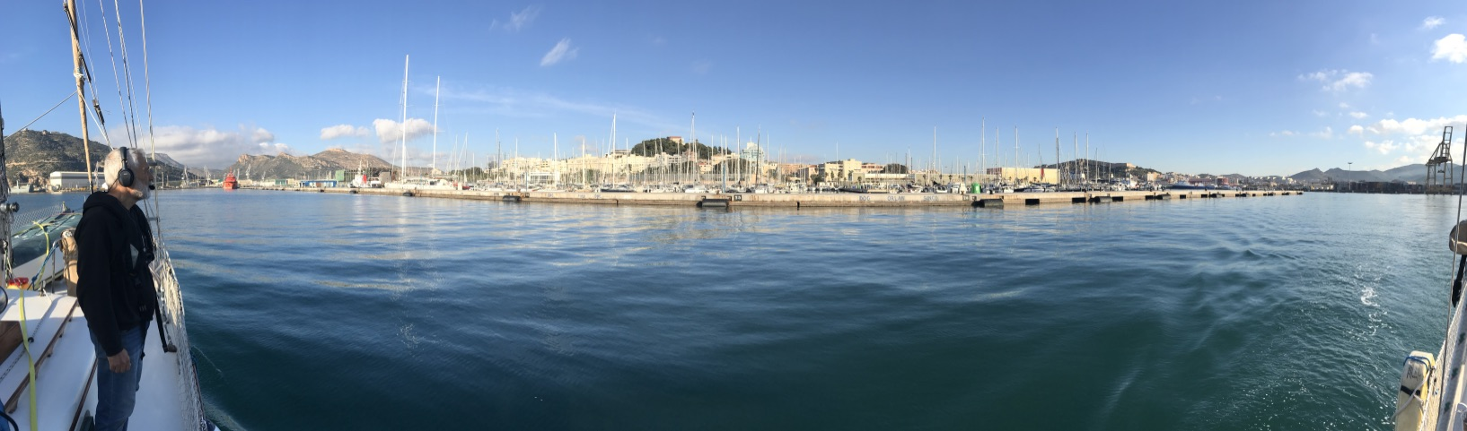
Juan serving as harbor pilot, guiding us into our slip at Real Club de Regatas de Cartagena.

Sailors around the world like to complain, and Spanish sailors are no different. Or perhaps more likely in this case they like to keep a good thing to themselves. Spanish sailors have long spread the rumor that in Cartagena, “The mountains are without trees, the forests are without wood, the ladies are all ugly, and the children are poorly educated.” Except for the rugged barrenness of the surrounding mountains, nothing from this yarn could be further from the truth. Cartagena is a beautiful seaport town; in fact, one of the most delightful cities we’ve visited in Andalucía.

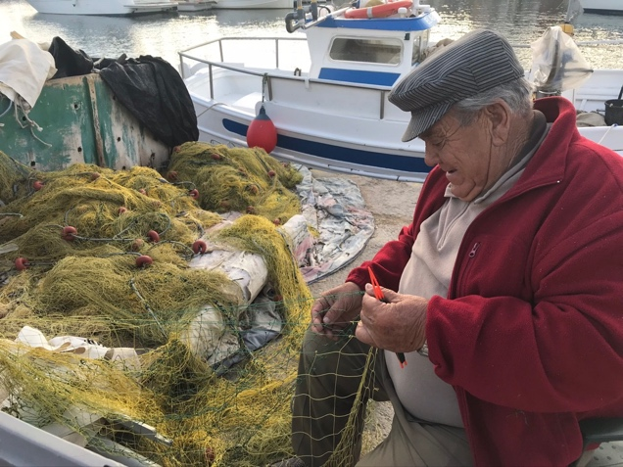
Juan relished talking about his hometown, and he wanted to show us what he could before he and Paloma returned to Rota. The first stop was the Museo Nacional de Arquelogía Subacuática, where one of his brothers had been a museum official for many years. He gave us a VIP tour of their collection, which is fascinating for the size and breadth of its well-preserved collection of Greek and Roman artifacts recovered from nearby waters dating back to the 7th century AD. After a noontime siesta, Juan and Paloma stopped by AFS and took us to lunch at the nearby fishing village of Cabo de Palos. The very Mediterranean waterfront is packed with seafood restaurants lining the tight dogleg entry into the crowded little harbor. Before lunch, however, we hiked to the nearby lighthouse on a promontory overlooking the Islas Ormigas (Ant Islets) and a large marine reserve.
A Cabo de Palos fisherman repairing his nets.

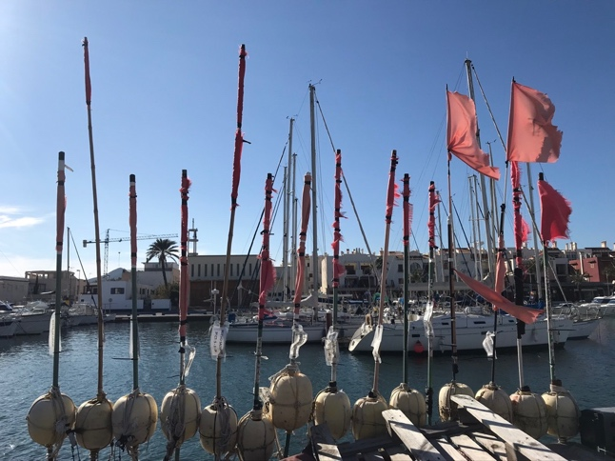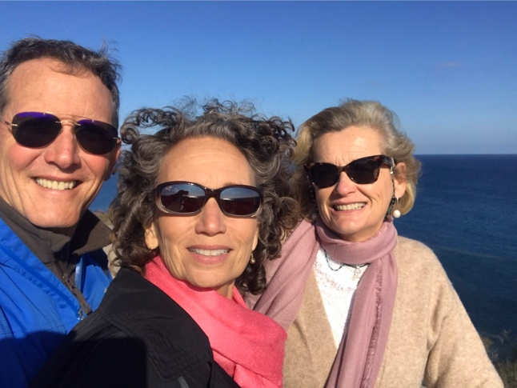
David, Vicki, and Paloma at the lighthouse overlooking Islas de las Ormigas.
The quaint fishing village of Cabo de Palos.
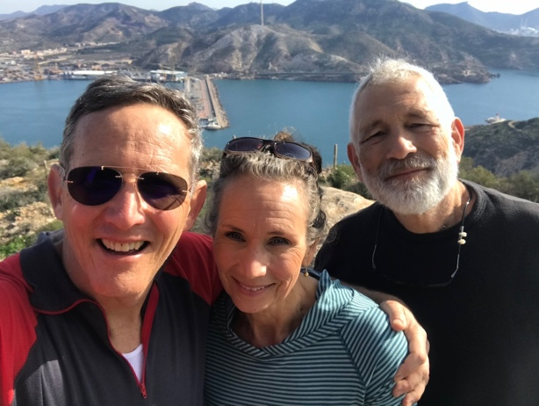
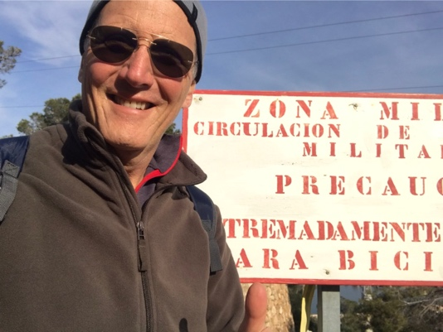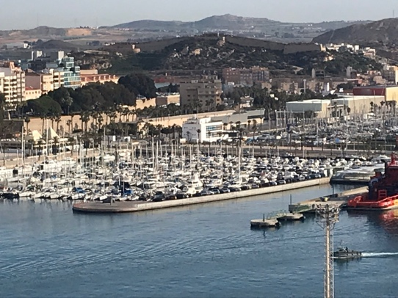
Scenes from our hike up to the seaside fortalezas overlooking Cartagena harbor.

The next day, Juan picked us up for a hike to two of the five fortalezas overseeing the urban area. We had a wonderful 3-hour excursion, climbing 200 meters above sea level to the top of two peaks, which gave us magnificent views of the port to the north and east, and the Mediterranean to the south. Later, Juan, Paloma, and their son Juanito stopped by AFS for lunch before Juan and Paloma drove back to Cádiz.

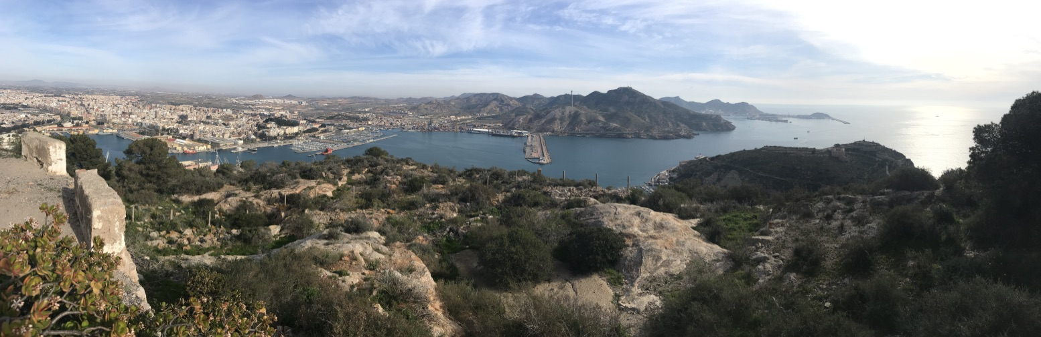
The very fine Museo Teataromano and the entrance to the Cartagena from a nearby hillside.

We spent the next few days touristing in Cartagena on our own, including the and the Museo Naval. The Teatroromano, in particular, is fascinating because the cultural treasure remained unknown (or more accurately, forgotten about) until 1990. The city had been built in layers over this 5th century Roman amphitheater. It was covered over by a fish market from the 1400s to 1800s, and later by a catholic church over part of it. Then in 1990, sections of the of amphitheater were rediscovered and a 13-year excavation begun.

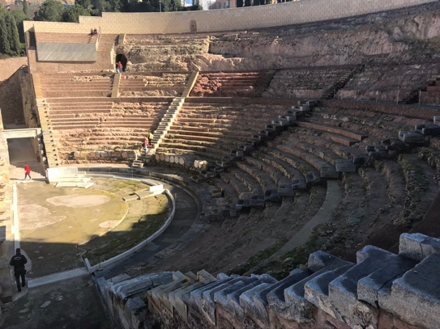
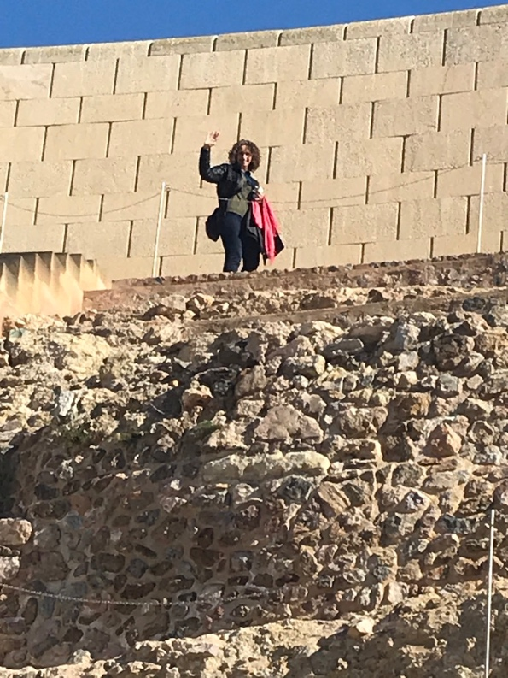
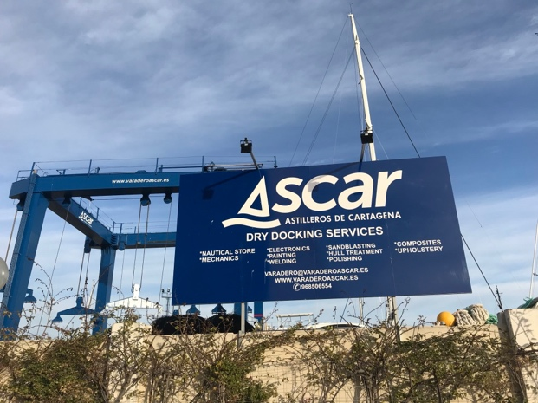
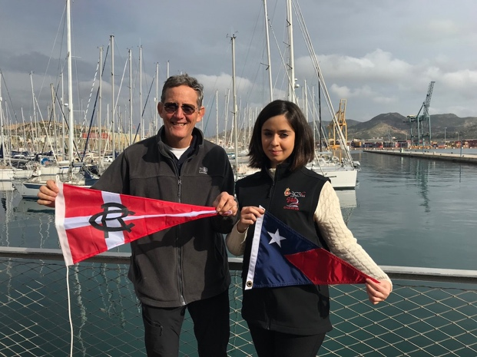
In addition, to museum going and general wandering around the town, we also took time out for ship’s work, of course and for making arrangements to haul out at the nearby Veradero Ascar, a busy full-service boatyard. We are now scheduled to haul out in early March in order to install a new Luke feathering propeller, replace an aging seacock in the engine room, and freshen up the antifouling bottom paint. But in the meantime, we’re spending most of February in north Florida and the DC area. North Florida has become our de facto logistics hub for medical, dental, and mail – not to mention our family ties a little further south; and the DC area is home to granddaughter Maebel and her parents, as well as our home station Capital Yacht Club. This visit to DC is extra special, however, as we await the arrival of our second grandchild, expected to be a boy on/about 14 February. More news to follow later about this, I’m sure.

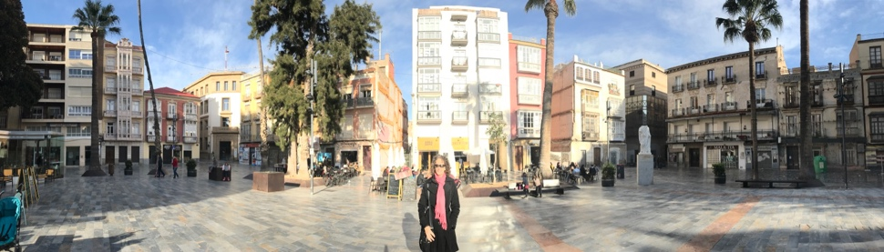
The huge travelift at the Astillero Ascar boatyard in Cartagena.
Exchanging burgees at the Royal Yacht Club de Regatas de Cartagena
Vicki in the picturesque Plaza de la Merced after taking an afternoon coffee.

